ASSIGNMENT-01
NAME :THAPETA GANGA DEVI
EMAIL :2004gangadevi@gmail.com
TITLE :DATA ANALYTICS WITH TABLEAU
ROLL NO :22AK1A0535
COLLEGE :AITS-TPT
“The following visualizations are created to clearly represent the data.”
- Bar Chart
- Pie Chart
- Stacked Bar Chart
- Line Chart
- Bubble Chart

1.BAR CHART
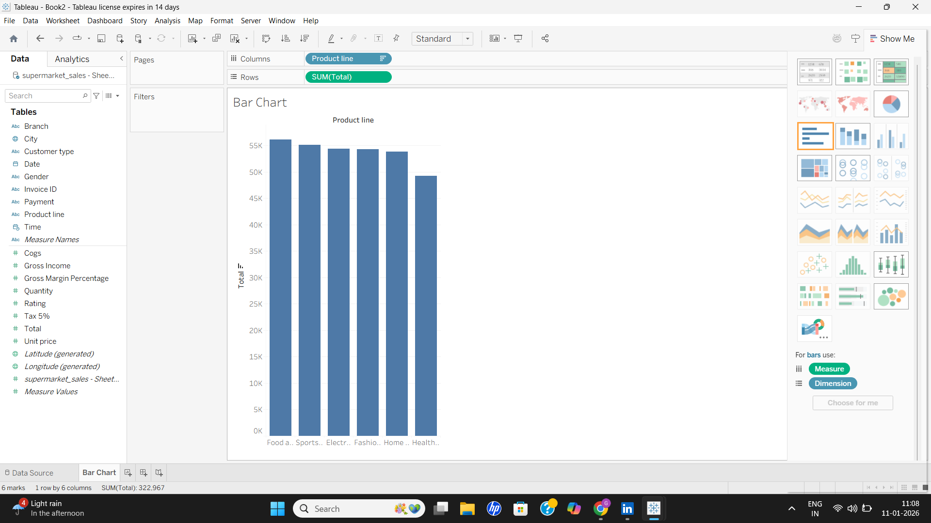
2.PIE CHART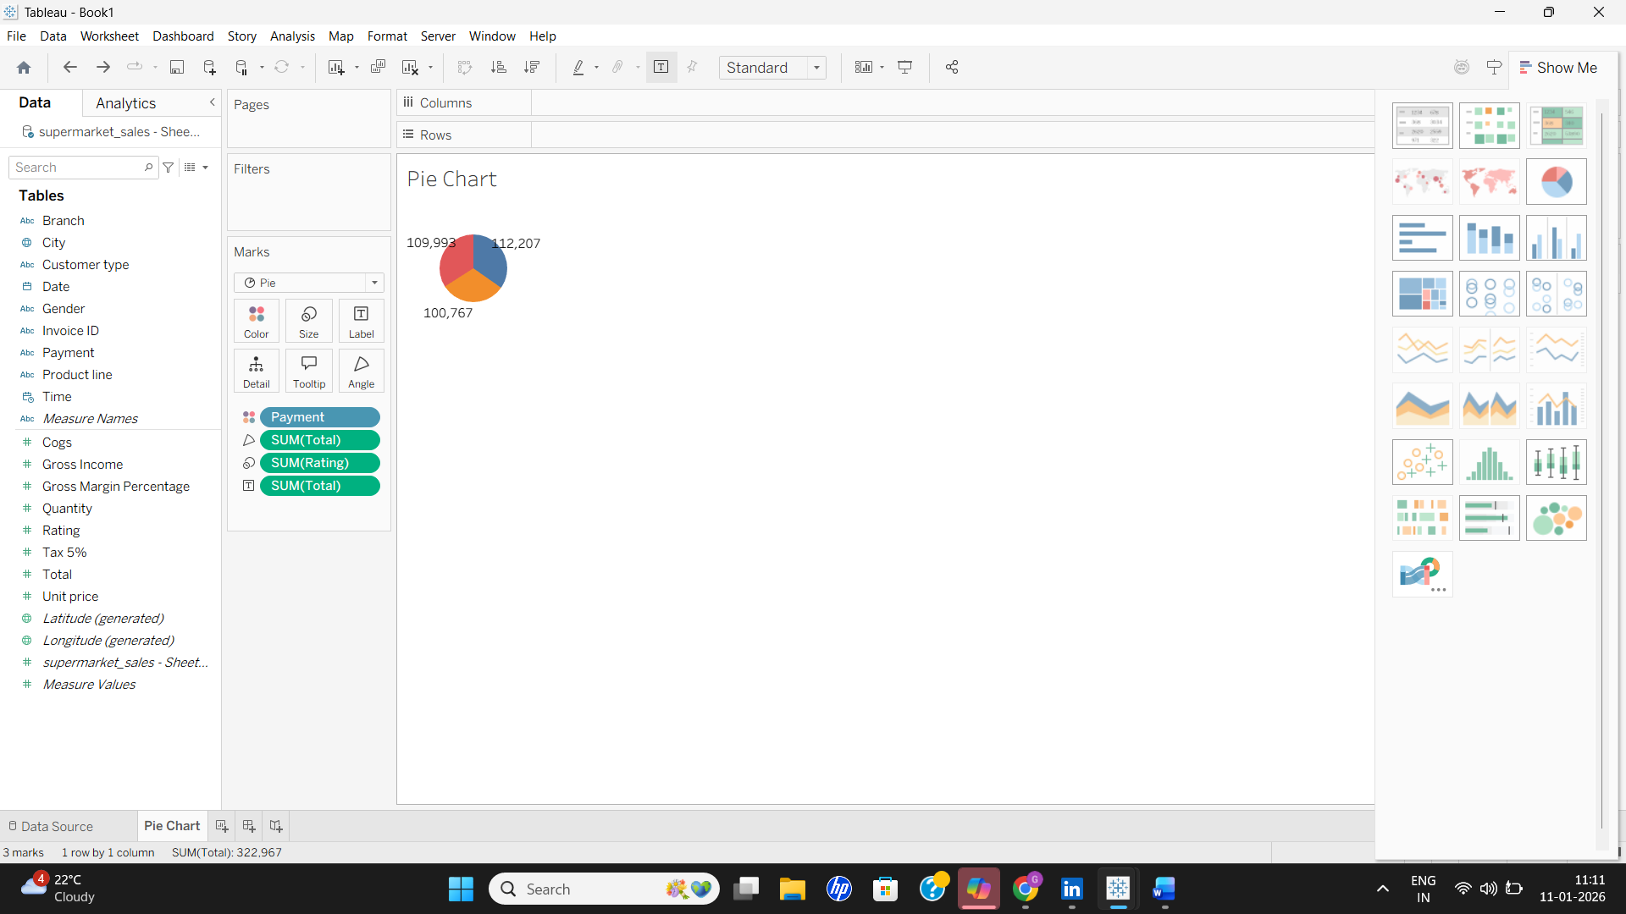

3.STACKED BAR CHART
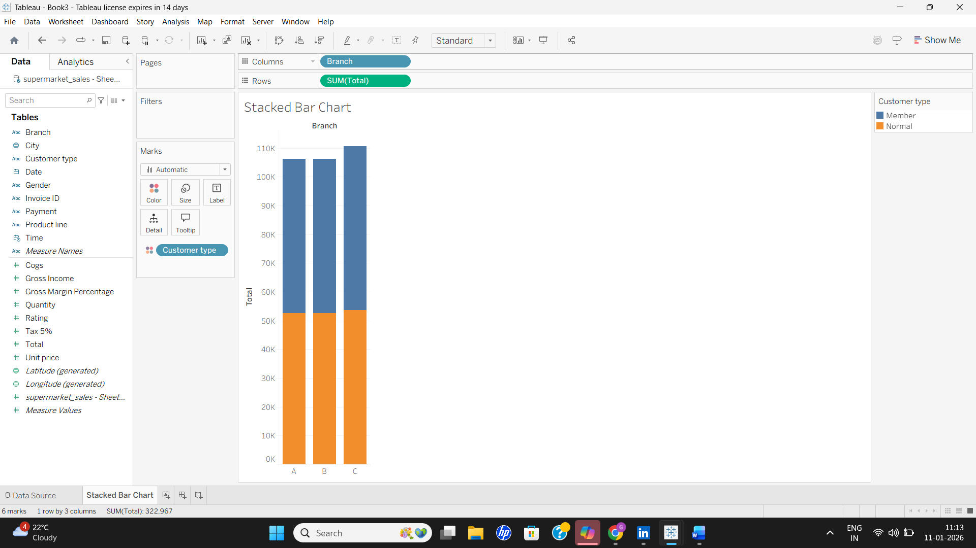
4.LINE CHART
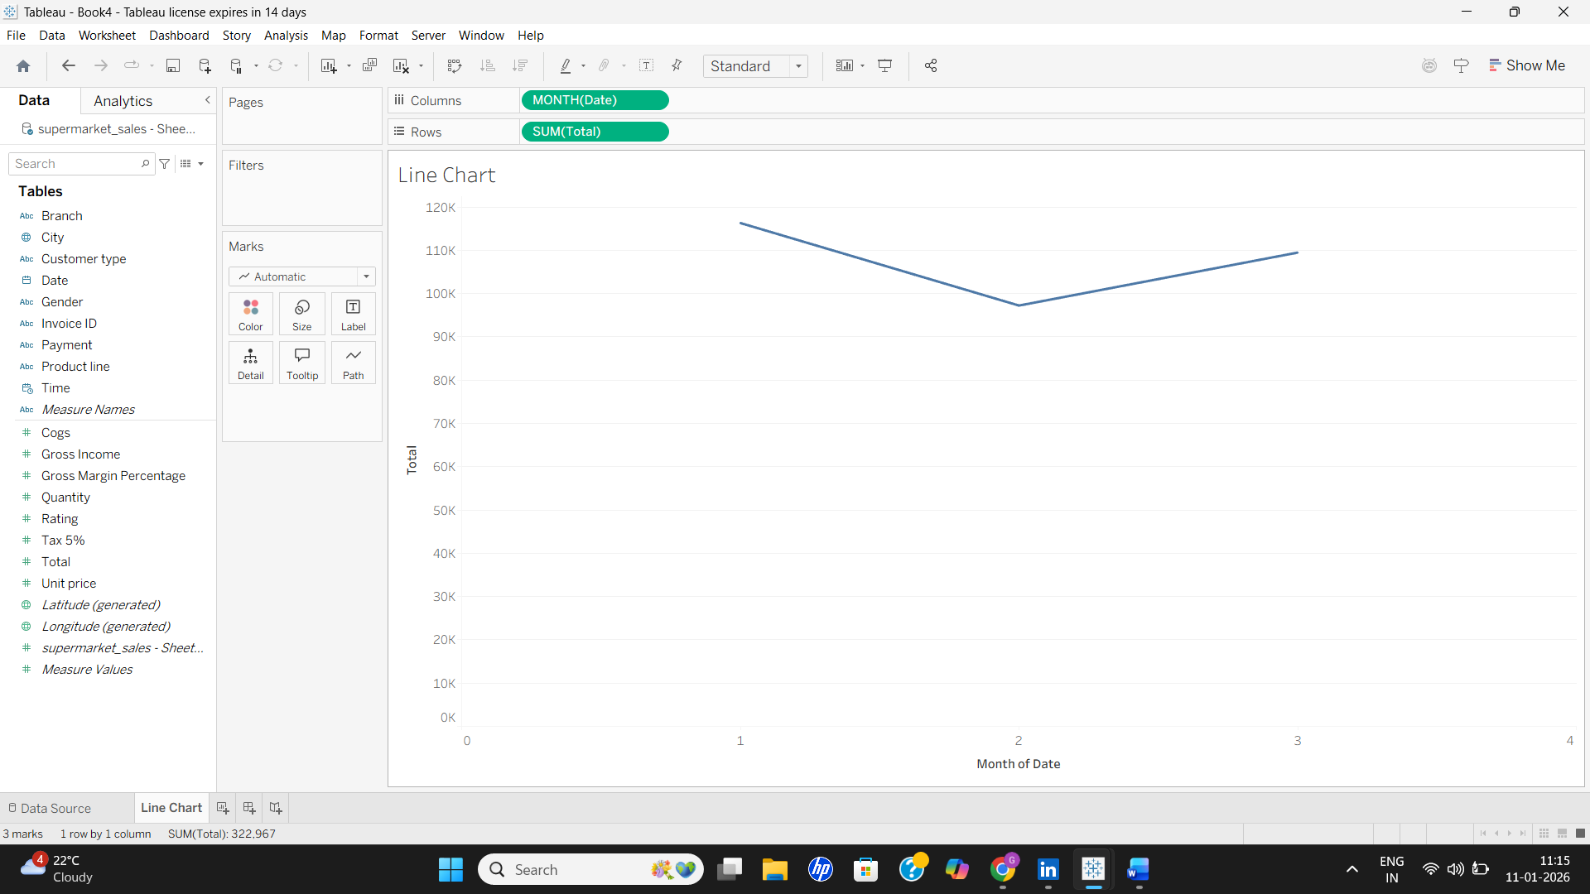

5.BUBBLE CHART
